GROUP D
Bacchus Winery Case Study
Milestone 1
Team Members | Verdis Moorer and Samuel Guizar
Case Study | Bacchus Winery
Deliverable | Business Rules, Assumptions, and Initial ERD

Business Rules and Assumptions
- The winery sells different types of wine.
- The winery purchases supplies and other items from multiple suppliers.
- A supplier can provide more than one type of item to the winery.
- An item may be provided by more than one supplier when needed.
- The winery has multiple distributors that sell the winery’s products.
- A distributor can sell more than one type of wine.
- A type of wine can be sold by more than one distributor.
- The winery requires sales reports from distributors to determine the quantity of each type of wine sold.
- A distributor can place multiple orders with the winery.
- Each distributor order is associated with one distributor.
- Distributors should be able to place orders online and track the status of their orders.
- Each purchase order is associated with one supplier.
- Each purchase order has an expected delivery date.
- A supplier delivery may arrive later than its expected delivery date, so the actual arrival date must be tracked separately.
- Each shipment includes a shipping date and an expected arrival date. The actual arrival date may also be recorded when the shipment is received.
- The winery maintains inventory counts for supplies and other items used by the business.
- The winery maintains distribution inventory counts for wine available for distributor orders.
- The inventory system should provide an updated method for tracking quantities on hand and inventory updates.
- Each employee works in one department.
- A department can have many employees.
- Employee time records include the number of hours worked by each employee.
- The winery needs to report hours worked by each employee for each quarter over the most recent four quarters.

Assumptions Used for the Initial ERD
- Each employee, supplier, distributor, wine, item, order, shipment, inventory record, and time record has a unique identifier.
- Wine is treated as a product/item so that inventory and ordering can be tracked consistently.
- Purchase orders can contain multiple items, and each purchase-order item records the quantity ordered.
- Distributor orders can contain multiple wines, and each order item records the quantity ordered.
- A shipment is associated with a purchase order and records shipping and arrival information.
- Inventory records distinguish between supply inventory and distribution inventory through an inventory type.
- Sales reports are associated with both the distributor and the wine so that wine sales can be analyzed by distributor and reporting date.
- Employee time records store a work date and hours worked; the quarter can be derived from the work date or stored for reporting purposes.
- The initial ERD focuses on the entities and relationships needed to satisfy the stated business rules. Additional attributes and constraints may be added as the project is refined.

Initial Entity Relationship Diagram
The ERD below represents the initial database design based on the business rules and assumptions above. Primary keys are identified as PK and foreign keys as FK. The relationships shown are primarily one-to-many relationships.
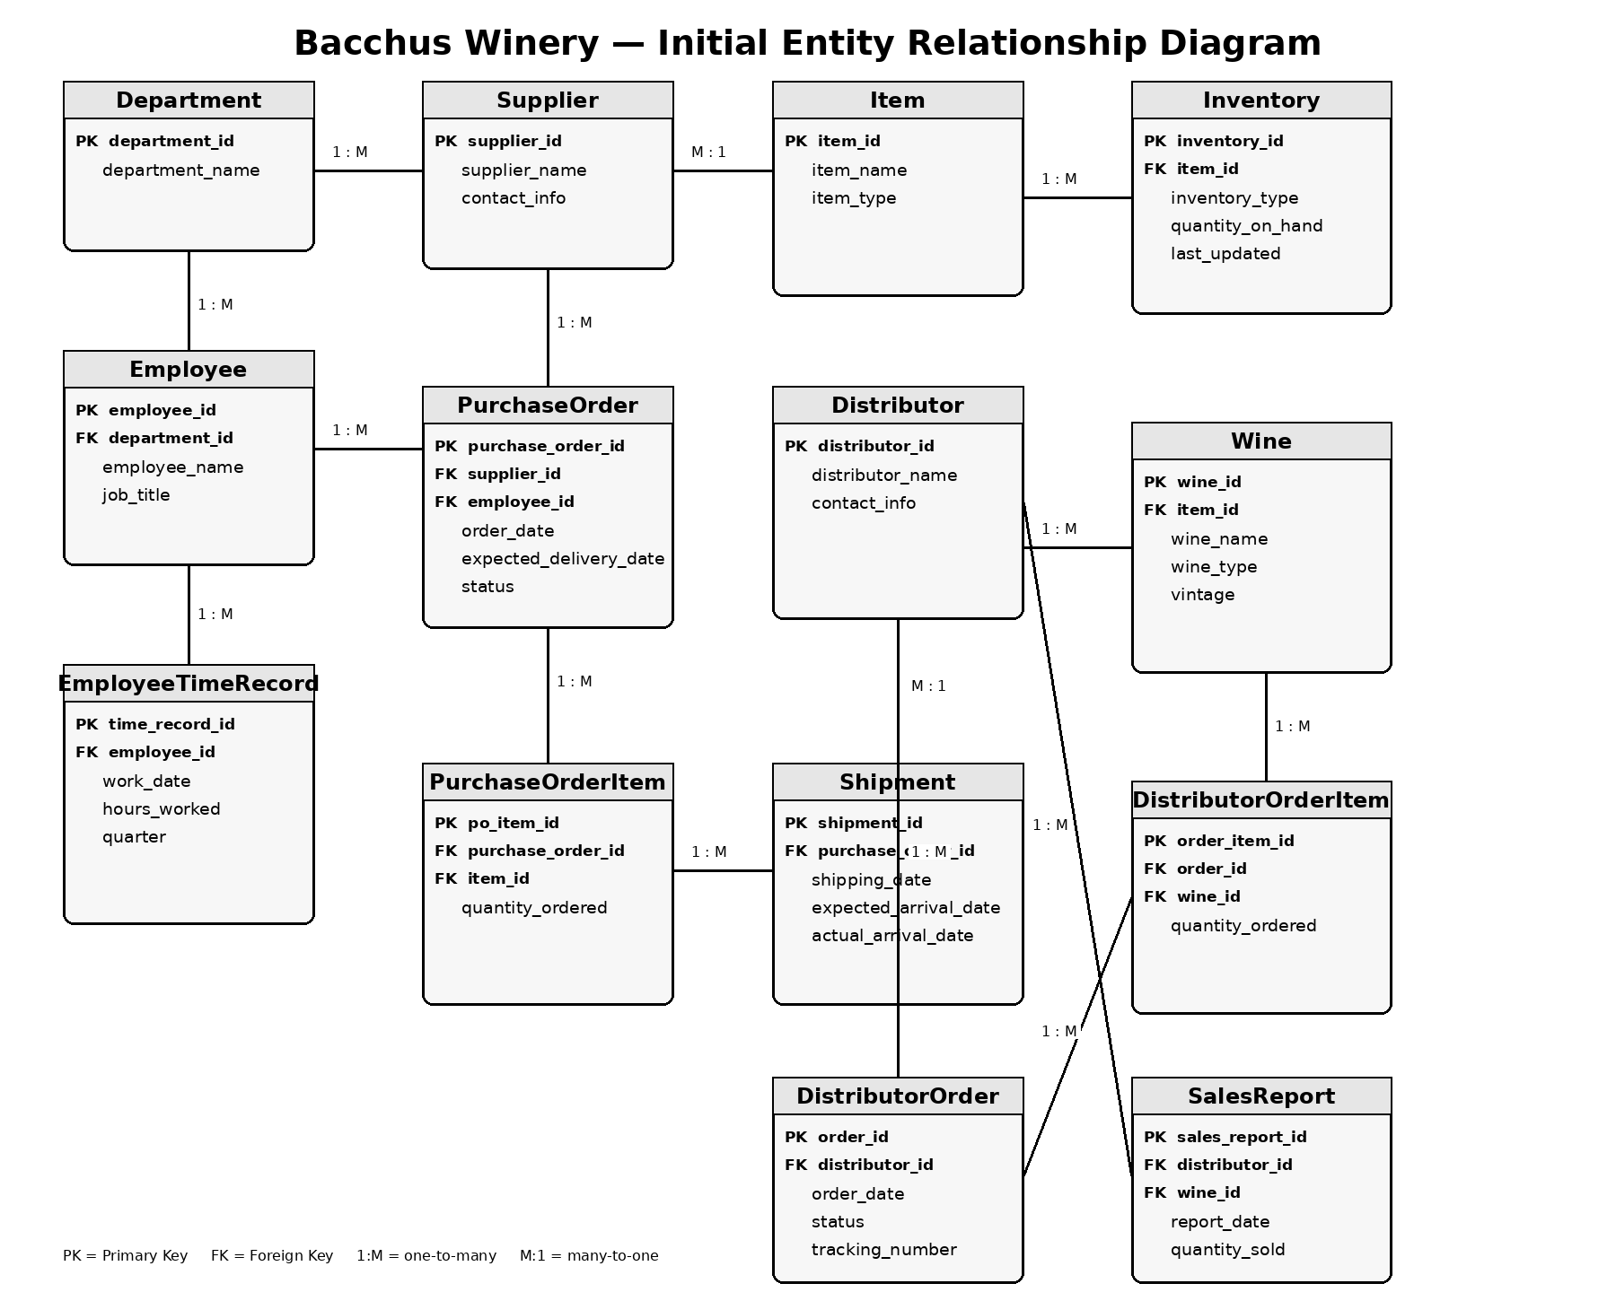

Initial ERD Entity Summary
Entity | Purpose
Department | Stores winery departments and supports the one-department-to-many-employees relationship.
Employee | Stores employee information and associates each employee with one department.
EmployeeTimeRecord | Stores employee work dates and hours for quarterly reporting.
Supplier | Stores suppliers that provide items to the winery.
PurchaseOrder | Records purchases made from suppliers, including expected delivery dates.
PurchaseOrderItem | Associates individual items and quantities with purchase orders.
Shipment | Tracks shipping, expected arrival, and actual arrival information for supplier deliveries.
Item | Represents supplies or other items purchased by the winery.
Inventory | Tracks quantities on hand for supply or distribution inventory.
Wine | Stores wine products sold by the winery.
Distributor | Stores distributors that sell the winery's wine.
DistributorOrder | Records orders placed by distributors and supports order tracking.
DistributorOrderItem | Associates wines and quantities with distributor orders.
SalesReport | Records reported wine sales by distributor and reporting date.

Group D — Bacchus Winery — Milestone 1

